Terraform 04

- Watch Terraform-04 video.
1. Terraform Versions

Terraform versions control compatibility, features, and behavior of your infrastructure code.

Terraform Core Version Constraint
Defined in the terraform block:
terraform {
required_version = ">= 1.5.0"
}

Common Version Constraints
Constraint | Meaning
>= 1.3.0 | Any version 1.3.0 or newer
~> 1.5 | Any 1.5.x version
<= 1.6.2 | Up to 1.6.2
!= 1.4.0 | Exclude version 1.4.0

Why Version Constraints Matter
-->Prevent breaking changes
-->Ensure consistent behavior across teams
-->Avoid unexpected failures in CI/CD pipelines

Provider Version Constraint

Specified inside required_providers:
terraform {
required_providers {
aws = {
source = "hashicorp/aws"
version = "~> 5.0"
}
}
}

Best Practices
-->Always lock provider versions
-->Avoid using latest
-->Use .terraform.lock.hcl for reproducibility

2. Terraform Data Sources

What is a Data Source?
A data source allows Terraform to read existing infrastructure instead of creating new resources.
Data sources are read-only.

Syntax
data "provider_type" "name" {
# filters
}

Common AWS Data Sources

Example: Get Existing VPC
data "aws_vpc" "default" {
default = true
}

Example: Get AMI
data "aws_ami" "amazon_linux" {
most_recent = true

filter {
name = "name"
values = ["amzn2-ami-hvm-*"]
}

owners = ["amazon"]
}

Referencing Data Source Output
data.aws_vpc.default.id

Use Cases
-->Fetch existing VPCs, subnets, AMIs
-->Reference IAM roles or security groups
-->Integrate Terraform with manually created resources

3. Terraform Meta-Arguments
Meta-arguments are special arguments supported by all resources.

count
Creates multiple instances of a resource.
resource "aws_instance" "web" {
count = 3
ami = "ami-123456"
instance_type = "t2.micro"
}

Accessing Instances
aws_instance.web[0].id
When to Use
-->Simple numeric repetition
-->Identical resources

for_each

Creates resources based on a map or set.

resource "aws_s3_bucket" "buckets" {
for_each = {
dev = "dev-bucket"
prod = "prod-bucket"
}

bucket = each.value
}

Access
aws_s3_bucket.buckets["dev"].id

count vs for_each
count | for_each
Index-based | Key-based
Risky for changes | Safer
Simple | Preferred

depends_on
Forces explicit dependency.

resource "aws_instance" "app" {
depends_on = [aws_db_instance.db]
}

When Needed
-->Terraform can’t infer dependency
-->Order-sensitive operations

lifecycle

Controls resource behavior.

resource "aws_instance" "example" {
lifecycle {
prevent_destroy = true
ignore_changes = [tags]
create_before_destroy = true
}
}

Lifecycle Arguments
Argument | Purpose
prevent_destroy | Prevent deletion
ignore_changes | Ignore attribute changes
create_before_destroy | Zero-downtime updates

provider
Use a specific provider configuration.

resource "aws_instance" "example" {
provider = aws.us_east
}

4. AWS Terraform (Terraform with AWS)

AWS Provider Configuration

provider "aws" {
region = "us-east-1"
}

Authentication Methods
-->Environment variables
-->AWS CLI credentials
-->IAM roles (recommended)
-->Shared credentials file

Multi-Region AWS Setup

provider "aws" {
alias = "us_west"
region = "us-west-2"
}
Usage:
resource "aws_s3_bucket" "west_bucket" {
provider = aws.us_west
bucket = "my-west-bucket"
}

Common AWS Resources

EC2

resource "aws_instance" "ec2" {
ami = data.aws_ami.amazon_linux.id
instance_type = "t2.micro"
}

S3

resource "aws_s3_bucket" "bucket" {
bucket = "my-terraform-bucket"
}

IAM Role

resource "aws_iam_role" "role" {
name = "example-role"
assume_role_policy = jsonencode({
Version = "2012-10-17"
Statement = [{
Effect = "Allow"
Principal = {
Service = "ec2.amazonaws.com"
}
Action = "sts:AssumeRole"
}]
})
}

2. Execute the script shown in the video.

- Version Constraints:
Changing in terraform providers version may get us into incompatability issues.
By default terraform will always try to downlaod the latest version of provider available from registry.
To make sure to use the specific version provider we can add the provider block in configura@on.
Example: =======

terraform {
required_providers {
local = {
source = "hashicorp/local"
version = "2.3.0"
}
}
}

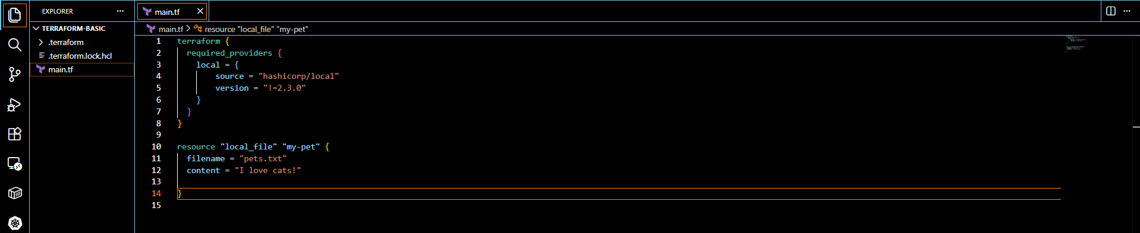

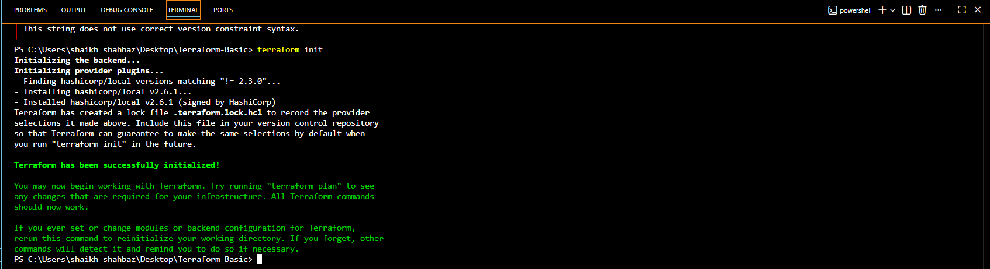

Version = “2.3.0” download the exact version
Version =”!=2.3.0” will not use the mentioned version
Version =”<2.3.0” lesser than the mentioned version
Version =”>2.3.0” greater then the given version
Version =”~>2.3.0” specific version or higher version

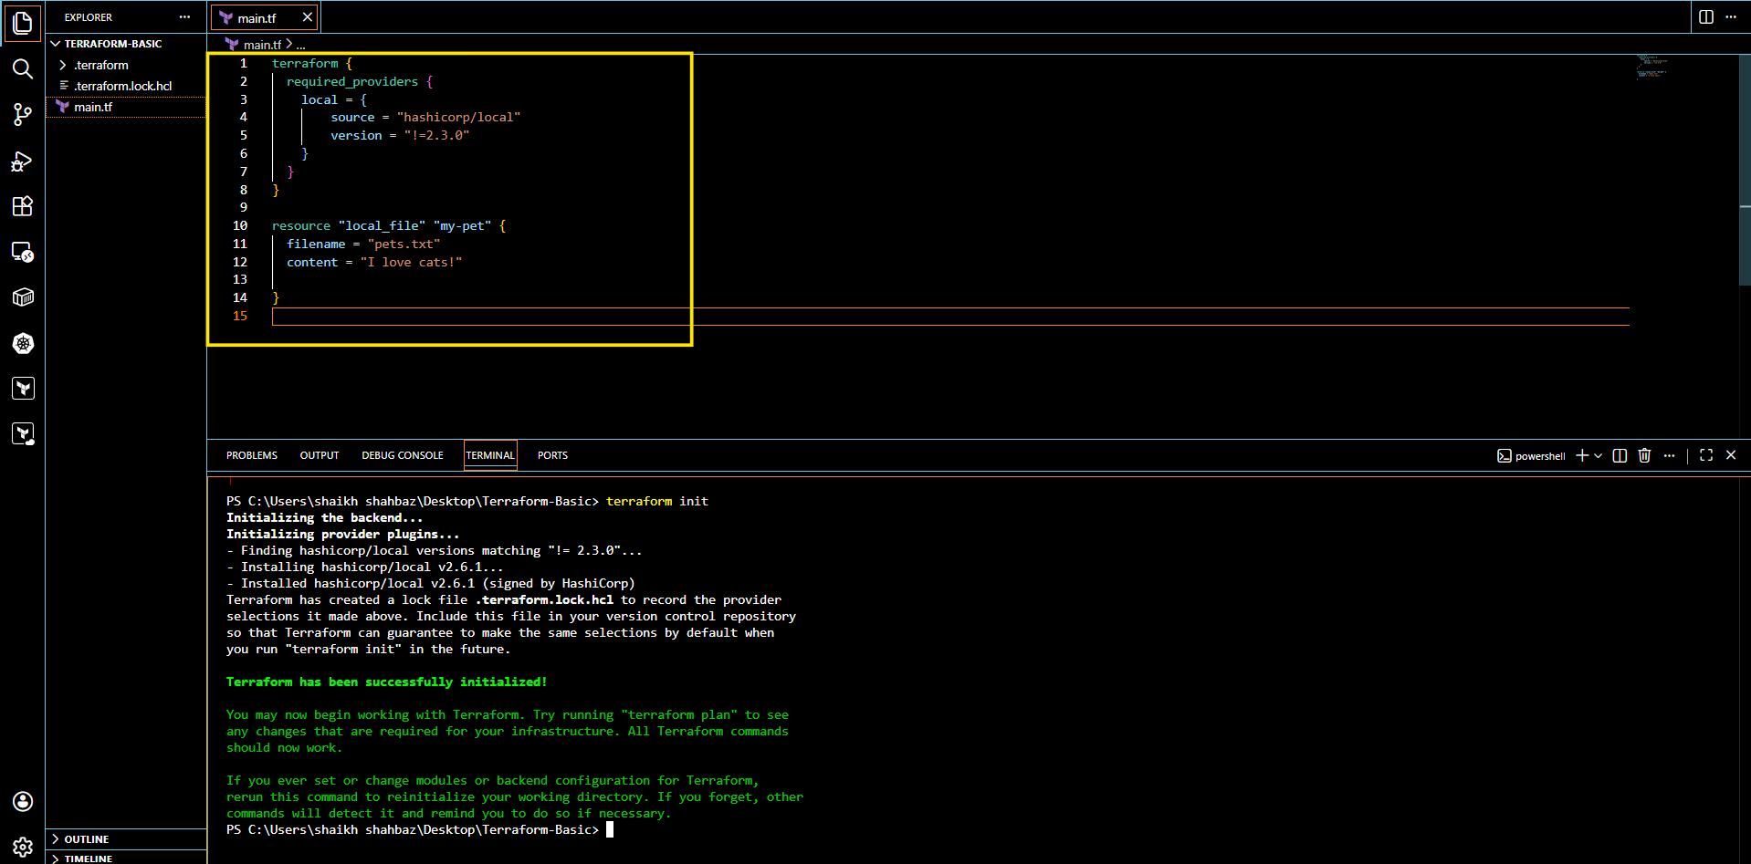

- Version =”!=2.3.0, <2.4.0”
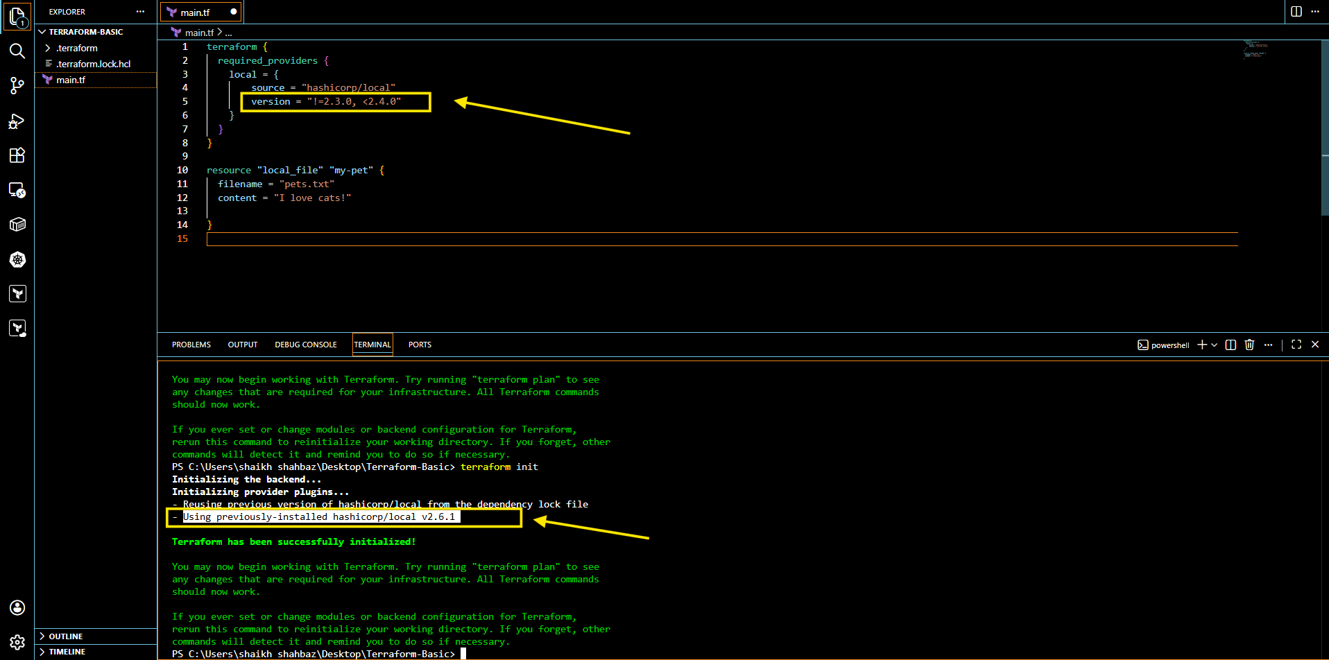

- Data sources:
Apart from terraform we have multiple other tools where the infra can be created.
Ex: ansible,salt,puppet,bash script,manual process.

Data sources are used to read the content of the infrastructure for example if we want terraform to read the content of the file which has been created by any other tool.
create a file called in dogs.txt in the same terrafrom working directory.

- main.tf

resource "local_file" "my-pet" {
filename = "copy.txt"
content = data.local_file.pet.content
}
data "local_file" "pet" {
filename = "pets.txt"
}

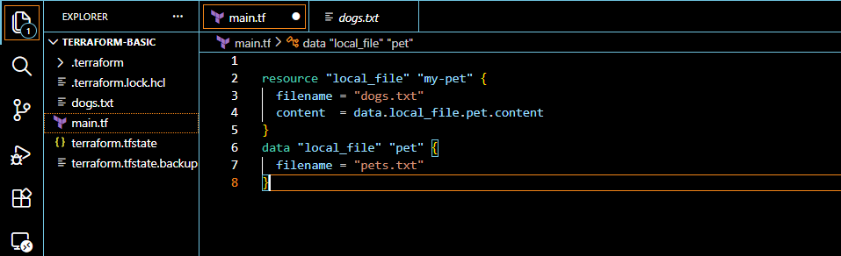
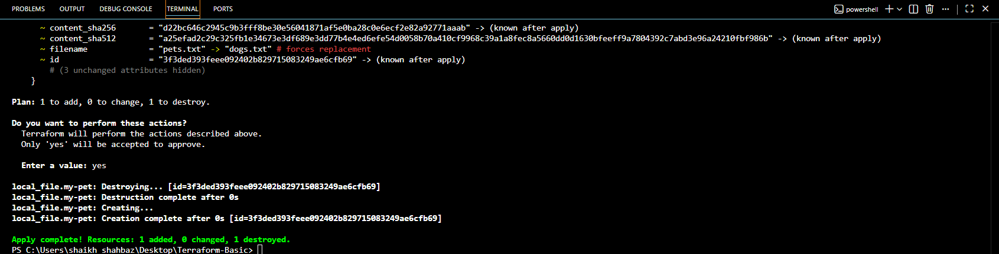

- Meta-Arguments:

Meta arguments are used if we want to create multiple resources.
Meta arguments can be used within any resource block to change the behaviour of the resources. Examples for meta arguments:
- Depends_on
- lifecycle rules
- Count
- For_each

- Example of count: If we use count as 3 then it will create 3 files with pet[0],pet[1],pet[2]

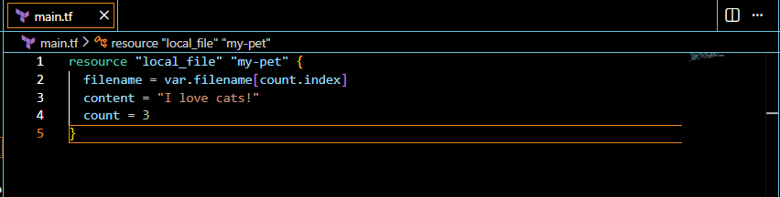
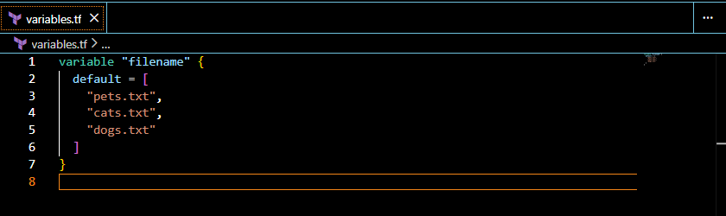
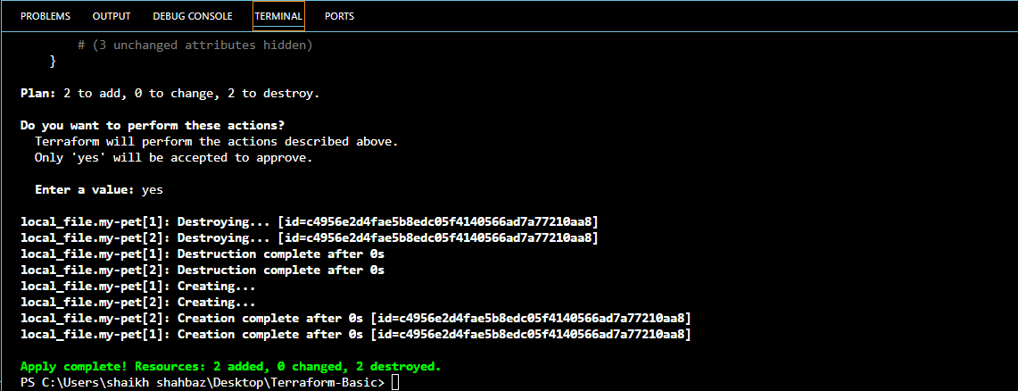

Count:
If we delete 1 file from variables.tf file then we need to add <count = length(var.filename)>
Then it will automatically delete the previously created file and will only keep recent files.

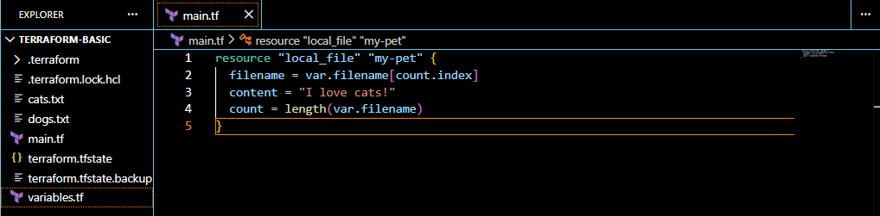
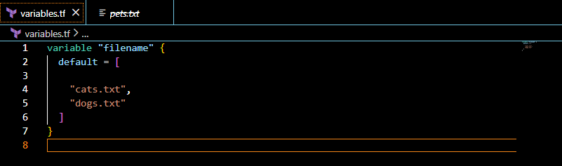
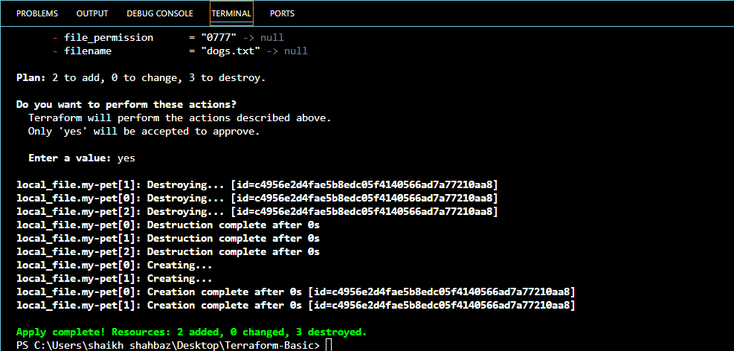

for_each:
Resource “local_file” “pet”
Filename = each.value
Content “I love wolf”
For_each = toset(var.filename)

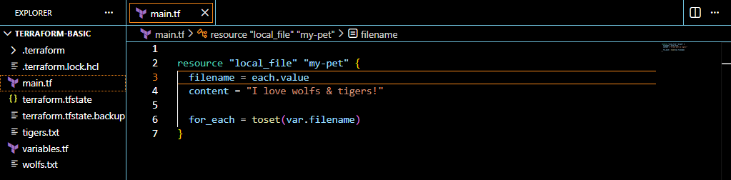
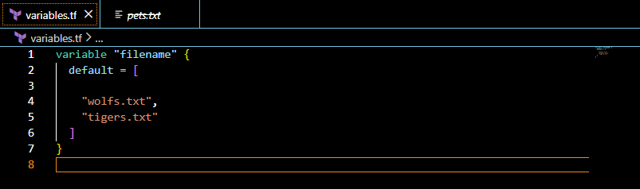
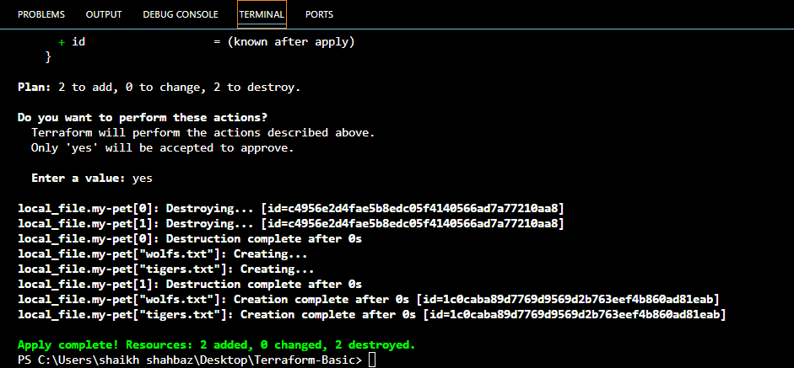

Terraform with AWS:

--> First we need to create a secret key and access key and configure it in laptop

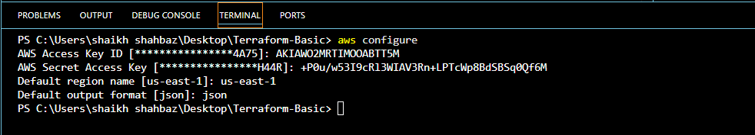

- Example Script to create AWS IAM user:

resource “aws_iam_user” “Admin-user” {
name = “lucy” tags = {
“description” = “Technical Team Lead”
}
}

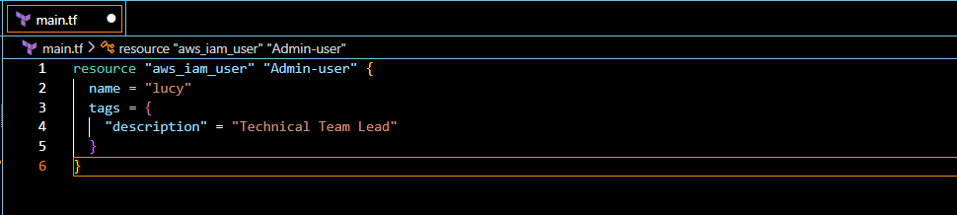

- terraform apply
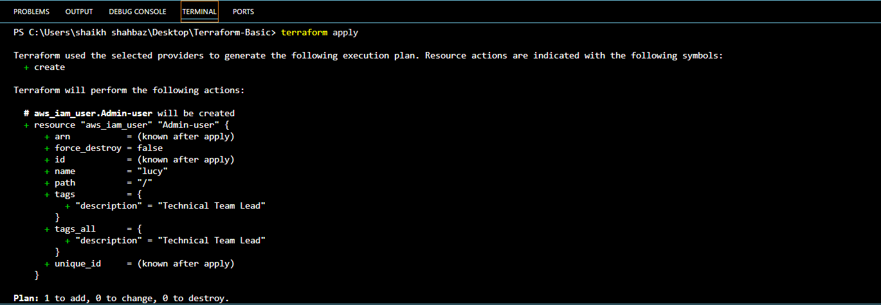

--> Now check your aws account
Goto IAM Users
We can see the user named: lucy
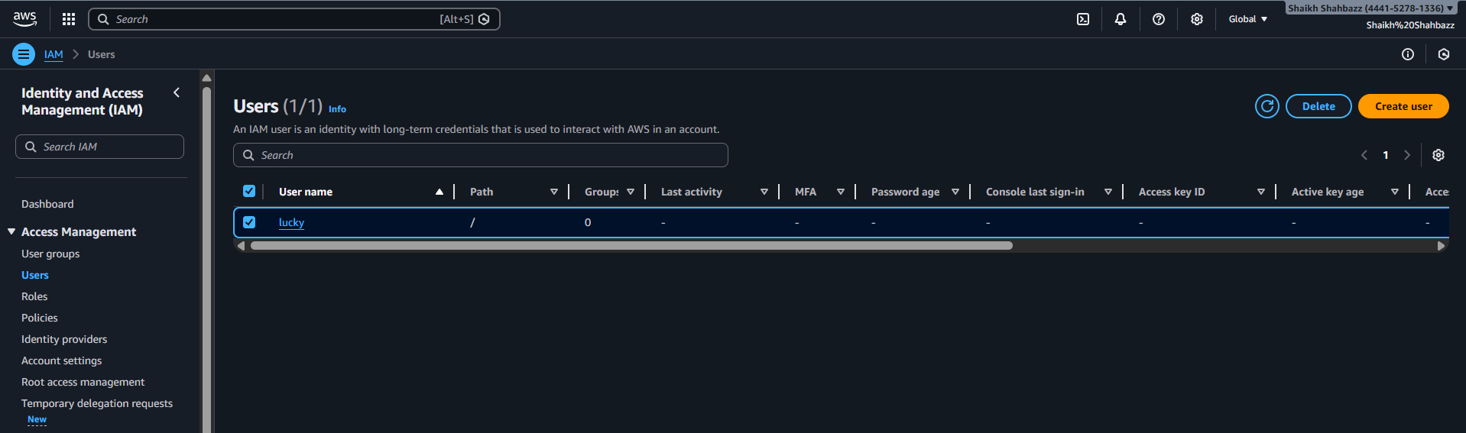

--> Now attach Policy to the user
resource "aws_iam_user" "Admin-user" {
name = "lucy" tags = {
"description" = "Technical Team Lead"
}
}
resource "aws_iam_policy" "adminuser" { name = "AdminUsers"
policy = <<EOF
{
"Version": "2012-10-17",
"Statement": [
{
"Sid": "1234567890",
"Effect": "Allow",
"Action": "*",
"Resource": "*"
}
]
}
EOF }
resource "aws_iam_user_policy_attachment" "lucy-admin-access"
{
user = aws_iam_user.Admin-user.name
policy_arn = aws_iam_policy.adminuser.arn
}
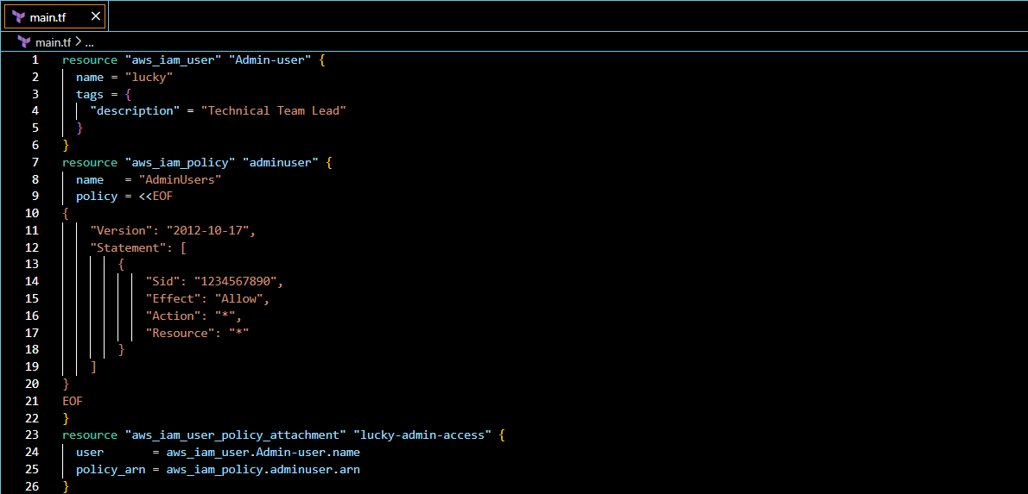
- terraform apply
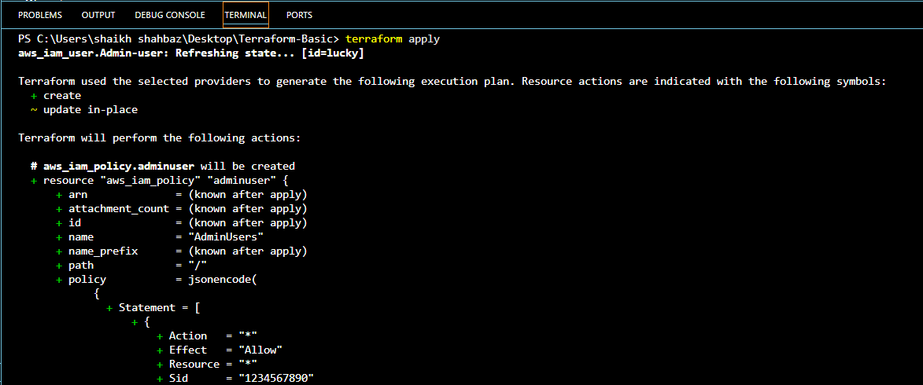
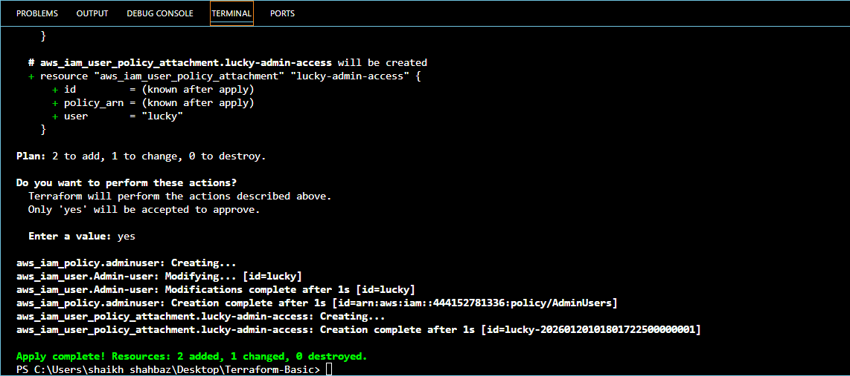

--> Now check the aws account and check the policy which we added to user named lucky
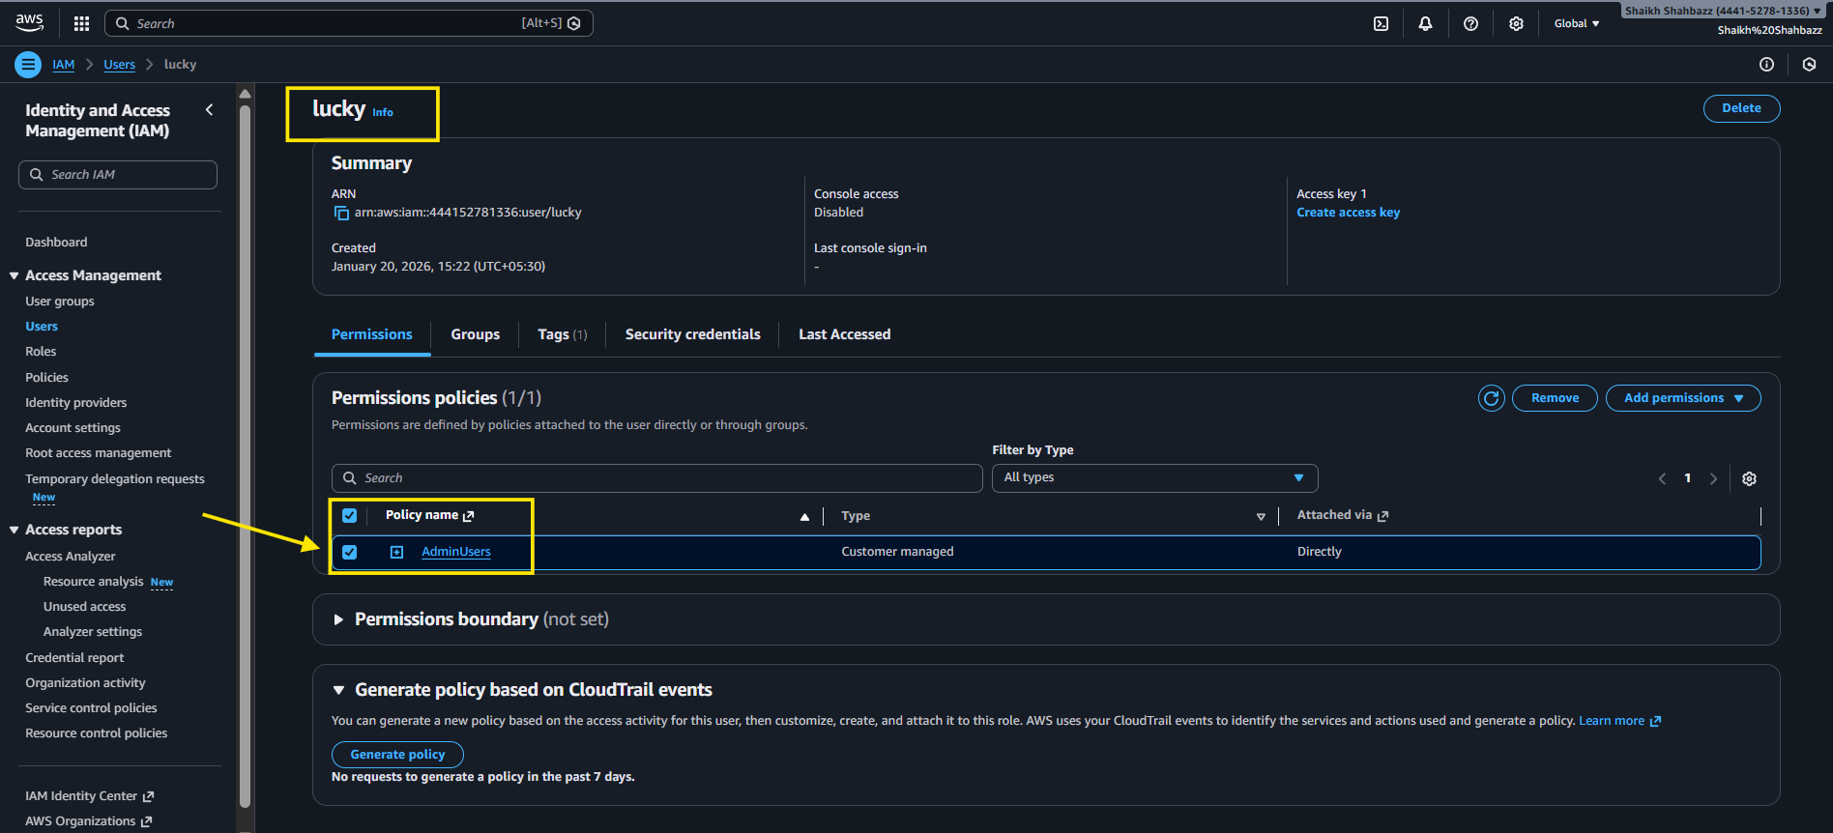
3. Integrate Terraform in Jenkins using the Terraform plugin.
Step 1: Install the Terraform Plugin in Jenkins
- Go to Jenkins Dashboard → Manage Jenkins → Plugins → Available Plugins.
- Search for Terraform.
- Install Terraform Plugin
- Restart Jenkins if required.

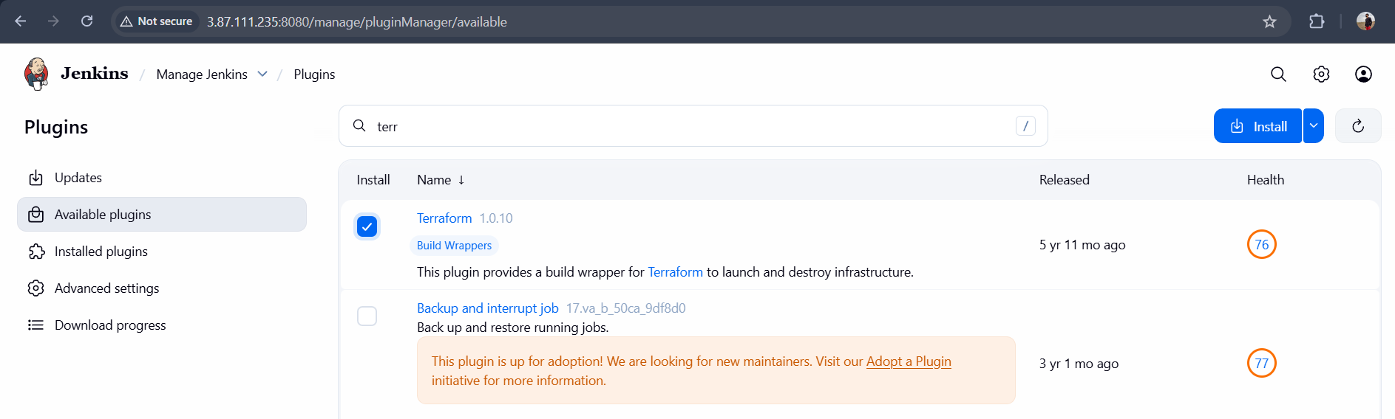

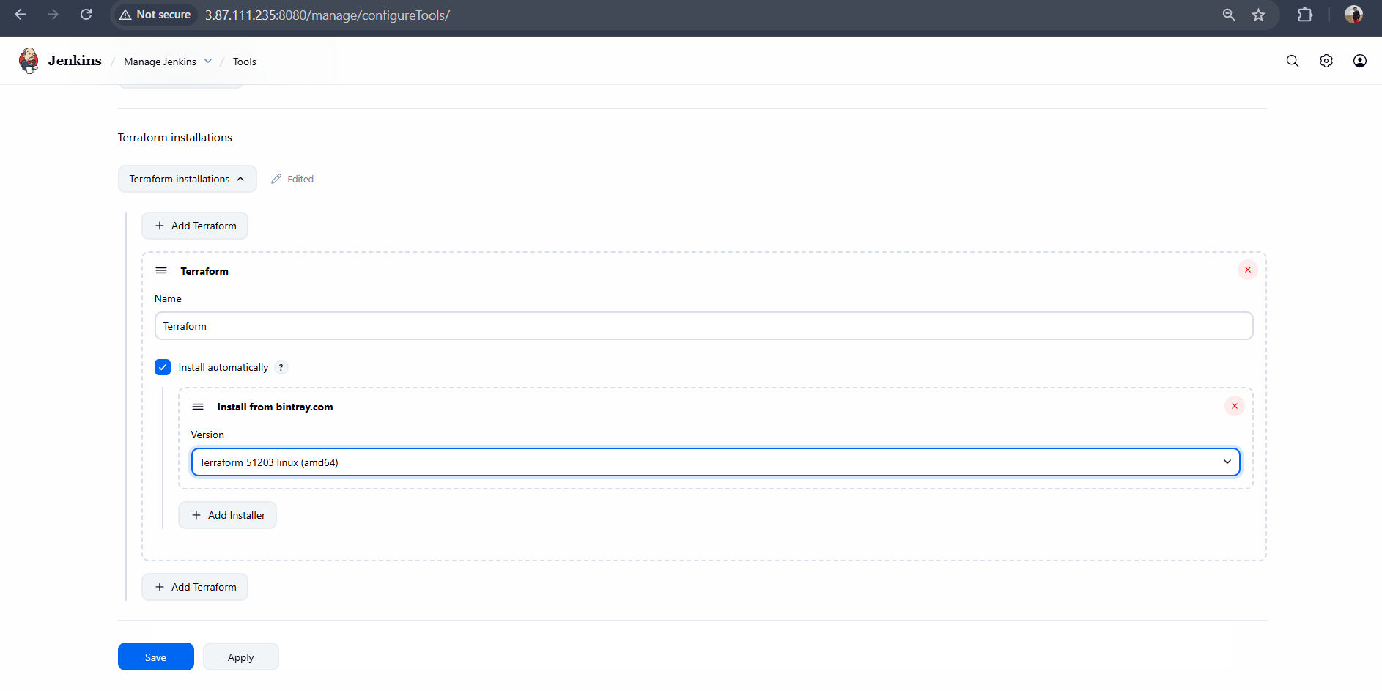

Step 2: Create a Jenkins job (Pipeline)
You can use either freestyle or pipeline

--> Inside GitHub
Add this code in main.tf in your repo file

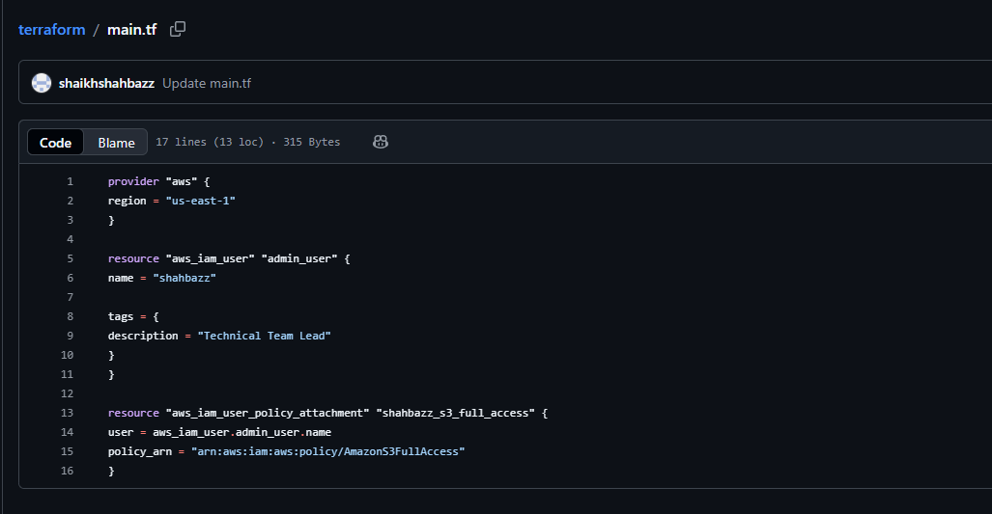

Add this code in Jenkins file in your repo

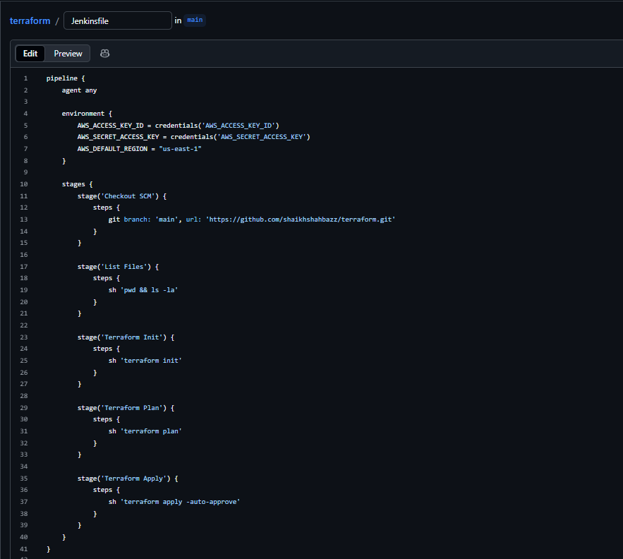

- Make sure you created credentials of your aws access key details in Jenkins GUI credentials

- Access key id: attach your access key id in secret text credentials
- Secret access key: attach your secret access key in secret text credentials

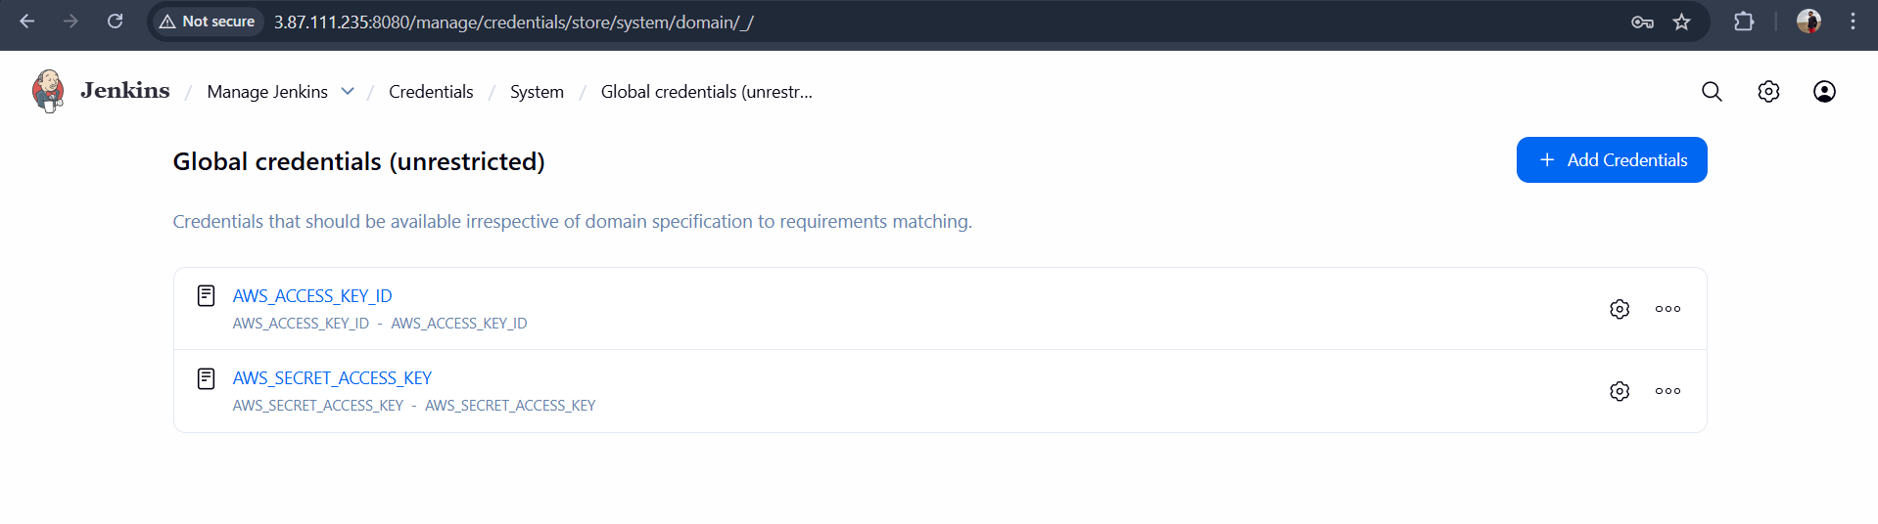

- Now create a job and Build
-->Attach your repo where we added jenkinsfile and main.tf file

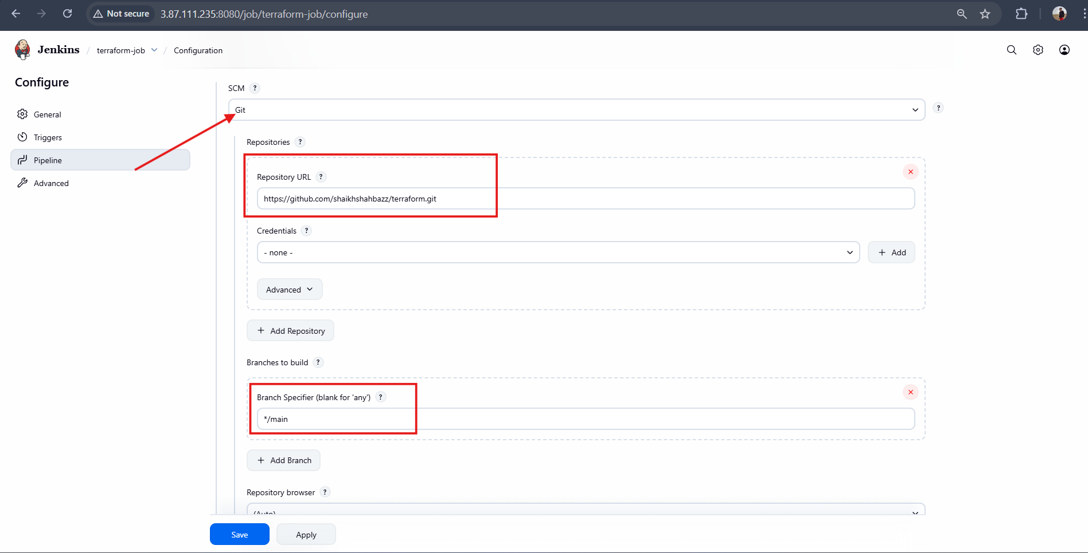

-->Click Build job

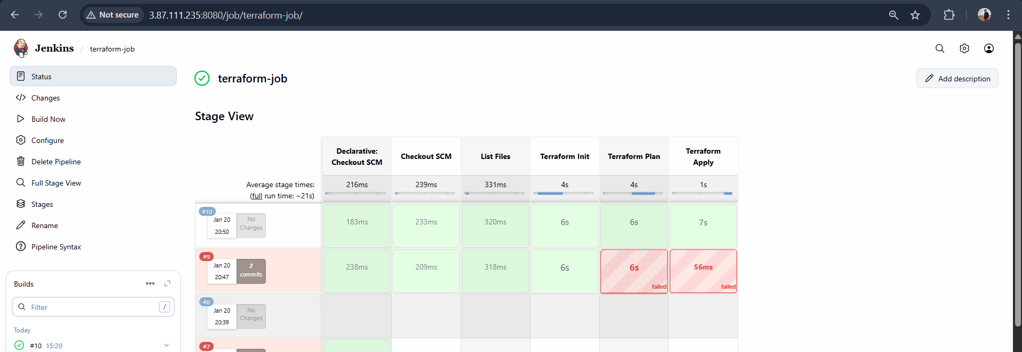

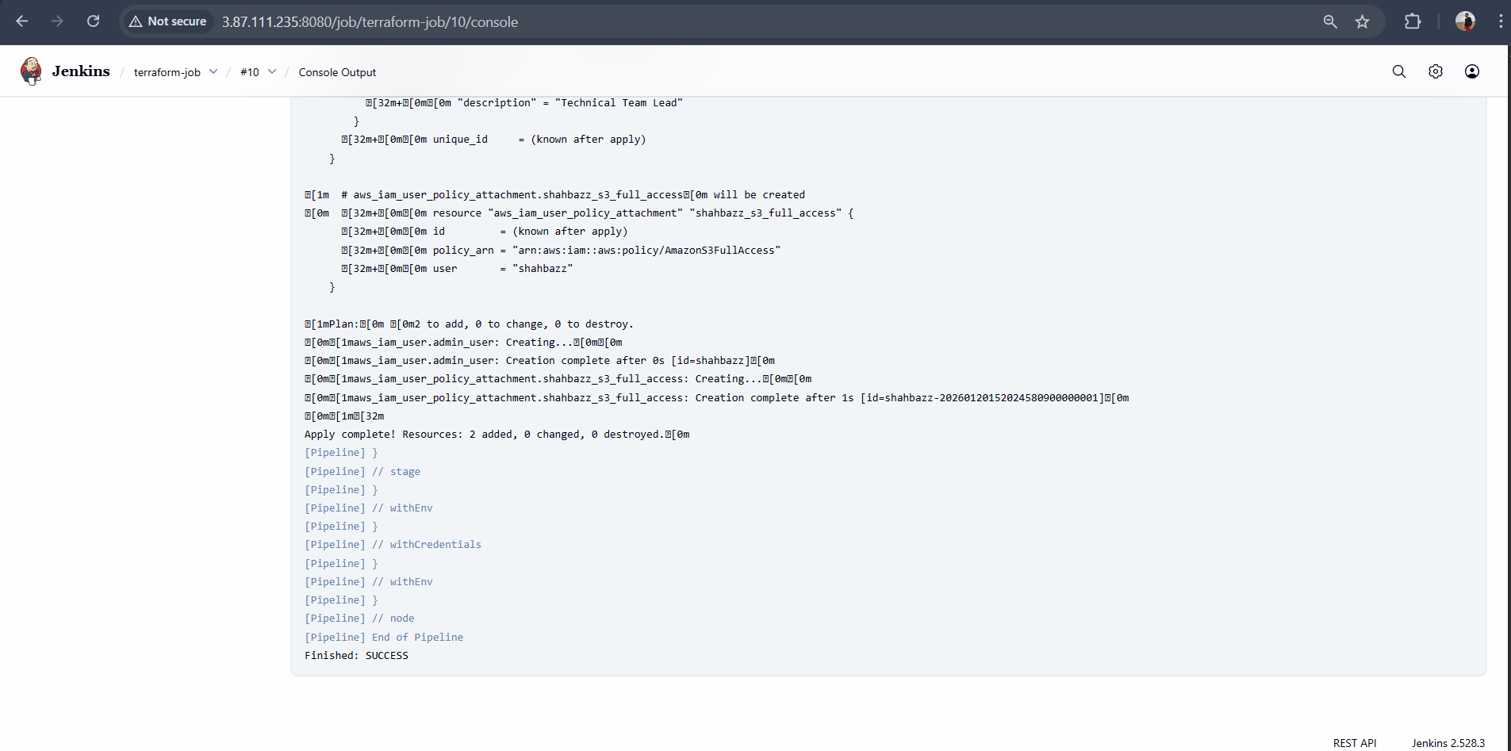

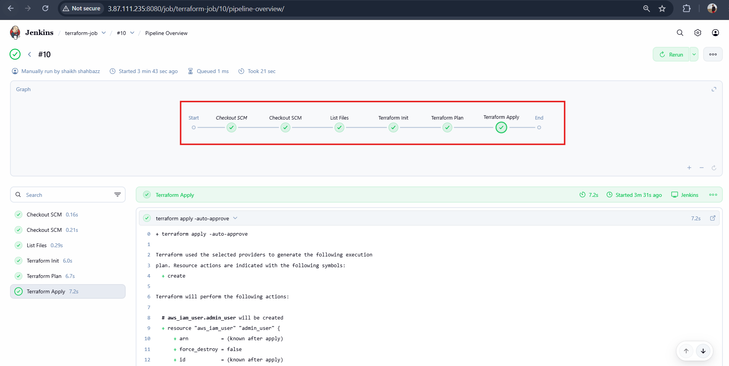

-->Now we can see that in AWS console in IAM users
User is created named <shahbaz> with <AmazonS3fullAccess>

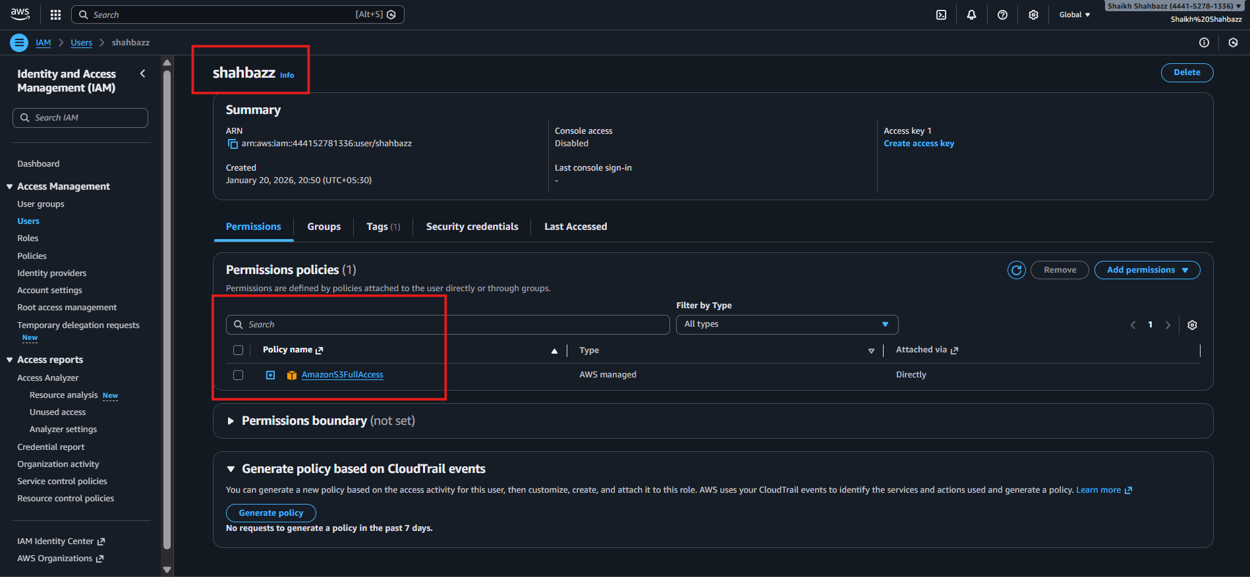

-->Here we are able to see the policy which we have given to user is available here

4. Create a CI/CD pipeline for a Nodejs Application: https://github.com/betawins/Trading-UI.git

Setup Jenkins
- Install required plugins: NodeJS plugin (to install Node.js run@me)

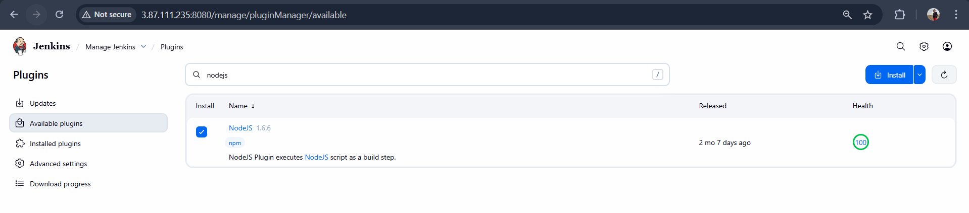

Configure NodeJS Tool in Jenkins:
- Goto Manage Jenkins Global Tool Configuration NodeJS installation
- Add a version (e.g., NodeJS 16.x)

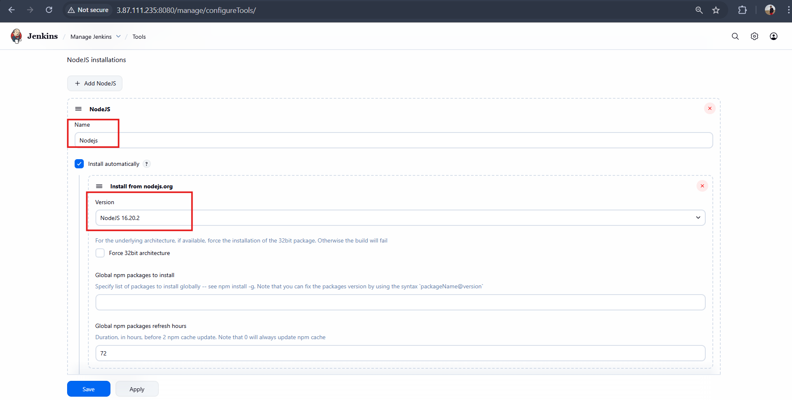

Fork the GitHub repo of the url
Then create Jenkinsfile in GitHub Repo

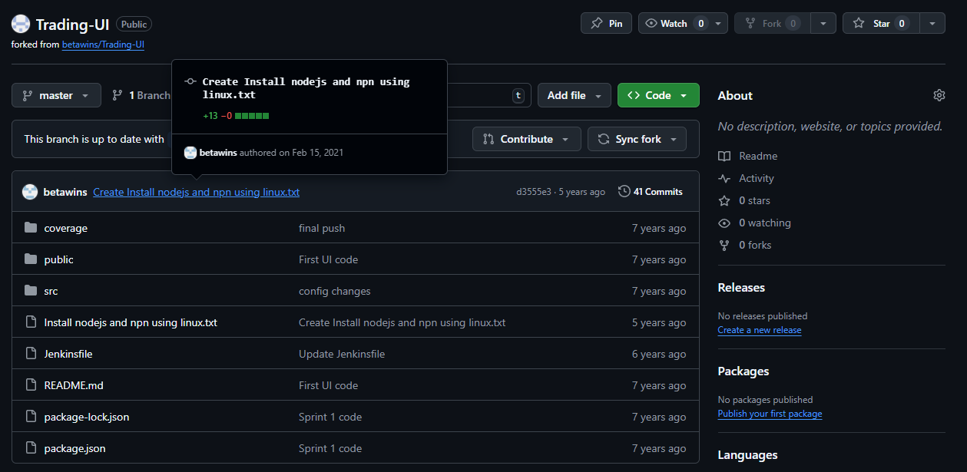

-->Inside Jenkinsfile pipeline

pipeline { agent any
tools {
nodejs "Nodejs"
}
stages {
stage('Checkout') { steps {
git url: 'https://github.com/shaikhshahbazz/Trading-UI.git', branch: 'master'
}
}
stage('Check Node & NPM') {
steps { sh 'node -v'
sh 'npm -v'
}
}
stage('Install Dependencies') {
steps {
sh 'npm install'
}
}
stage('Build') { steps {
sh 'CI=false npm run build'
}
}
stage('Test') {
steps {
sh 'npm test || echo "No tests found"'
}
}
}
}
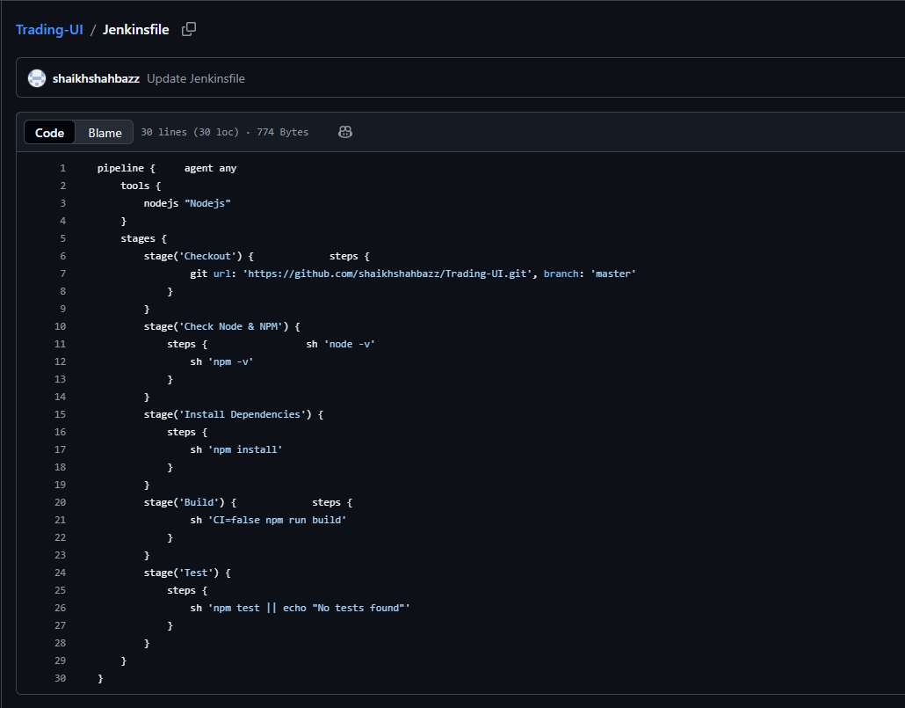

-->Now create a job and give name Nodejs-Job
-->Attach the repo url were we edited our jenkinsfile

- New item Pipeline Give name Select “Pipeline from SCM”
- Choose Git and provide repo URL

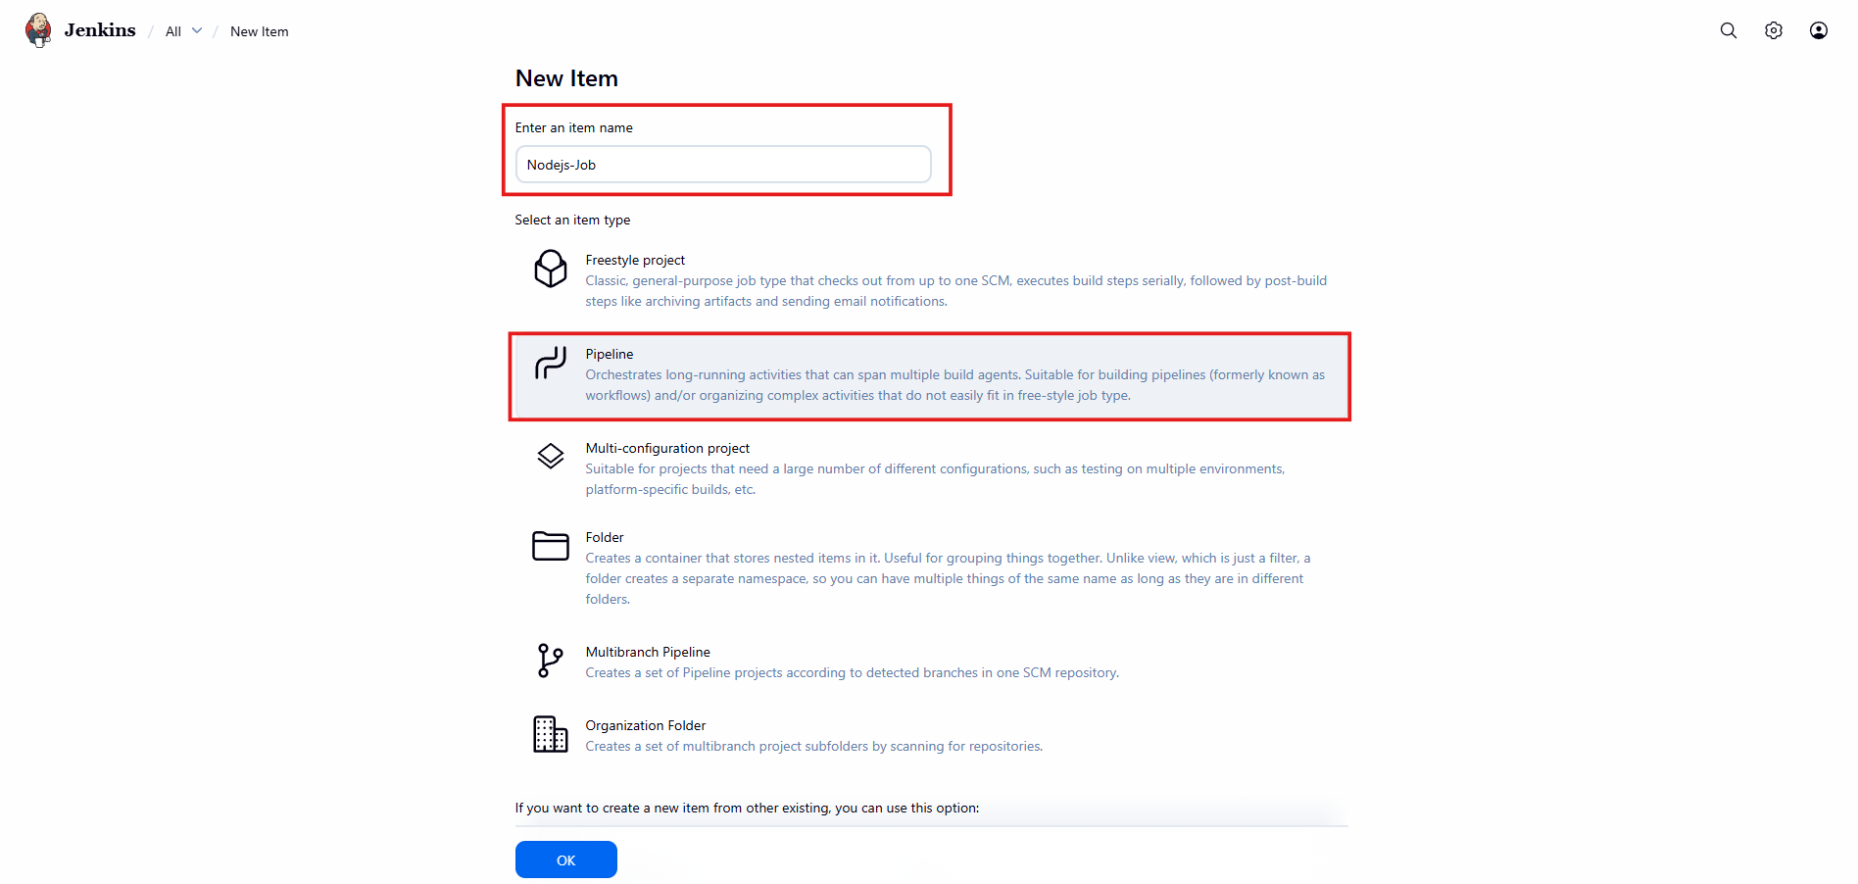

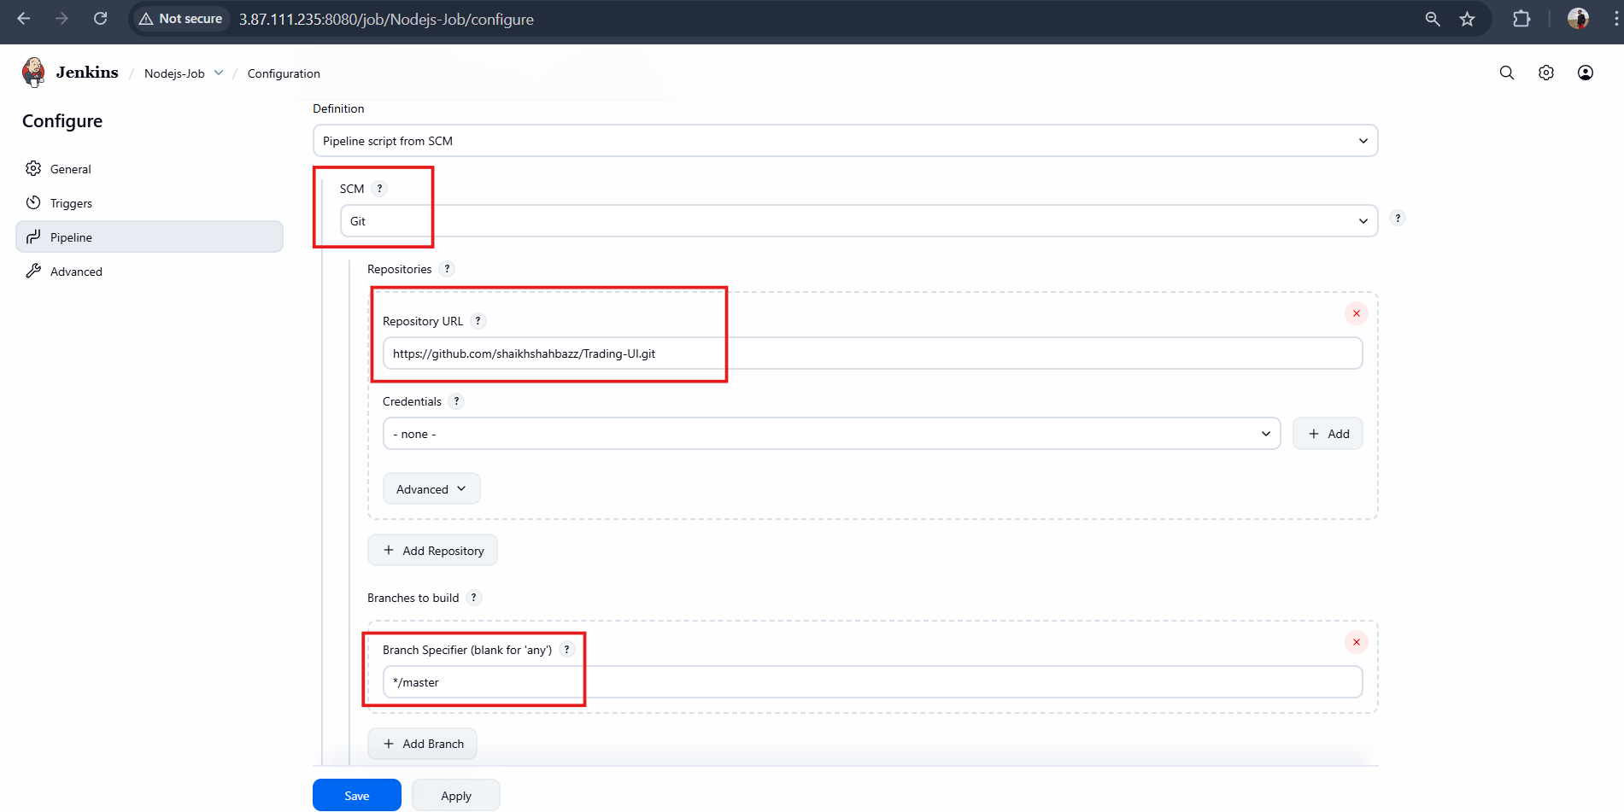

Save and Click Build Now

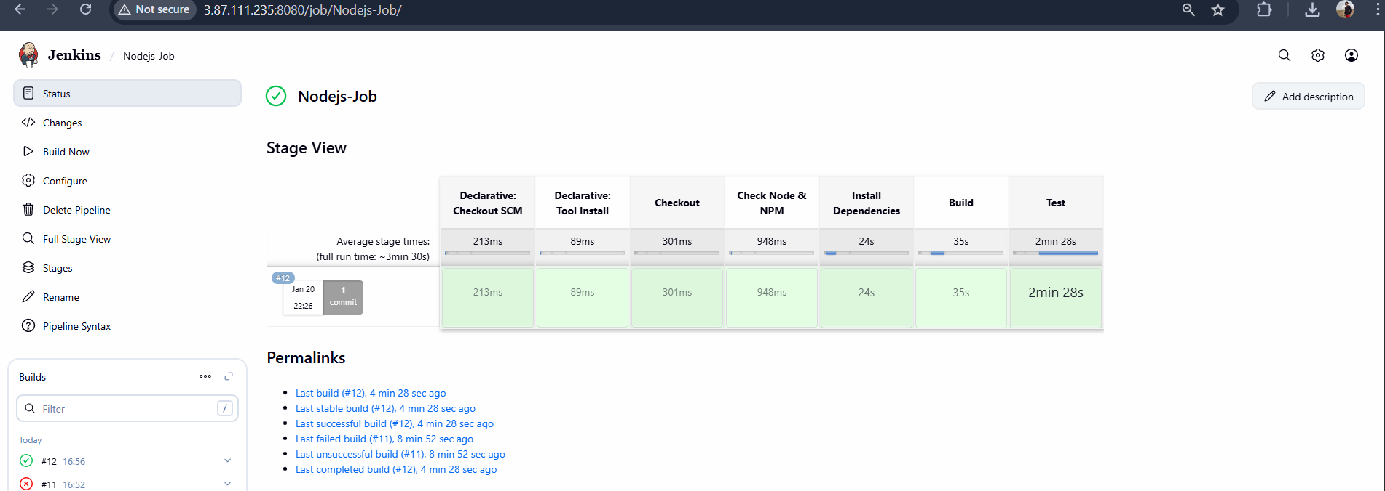

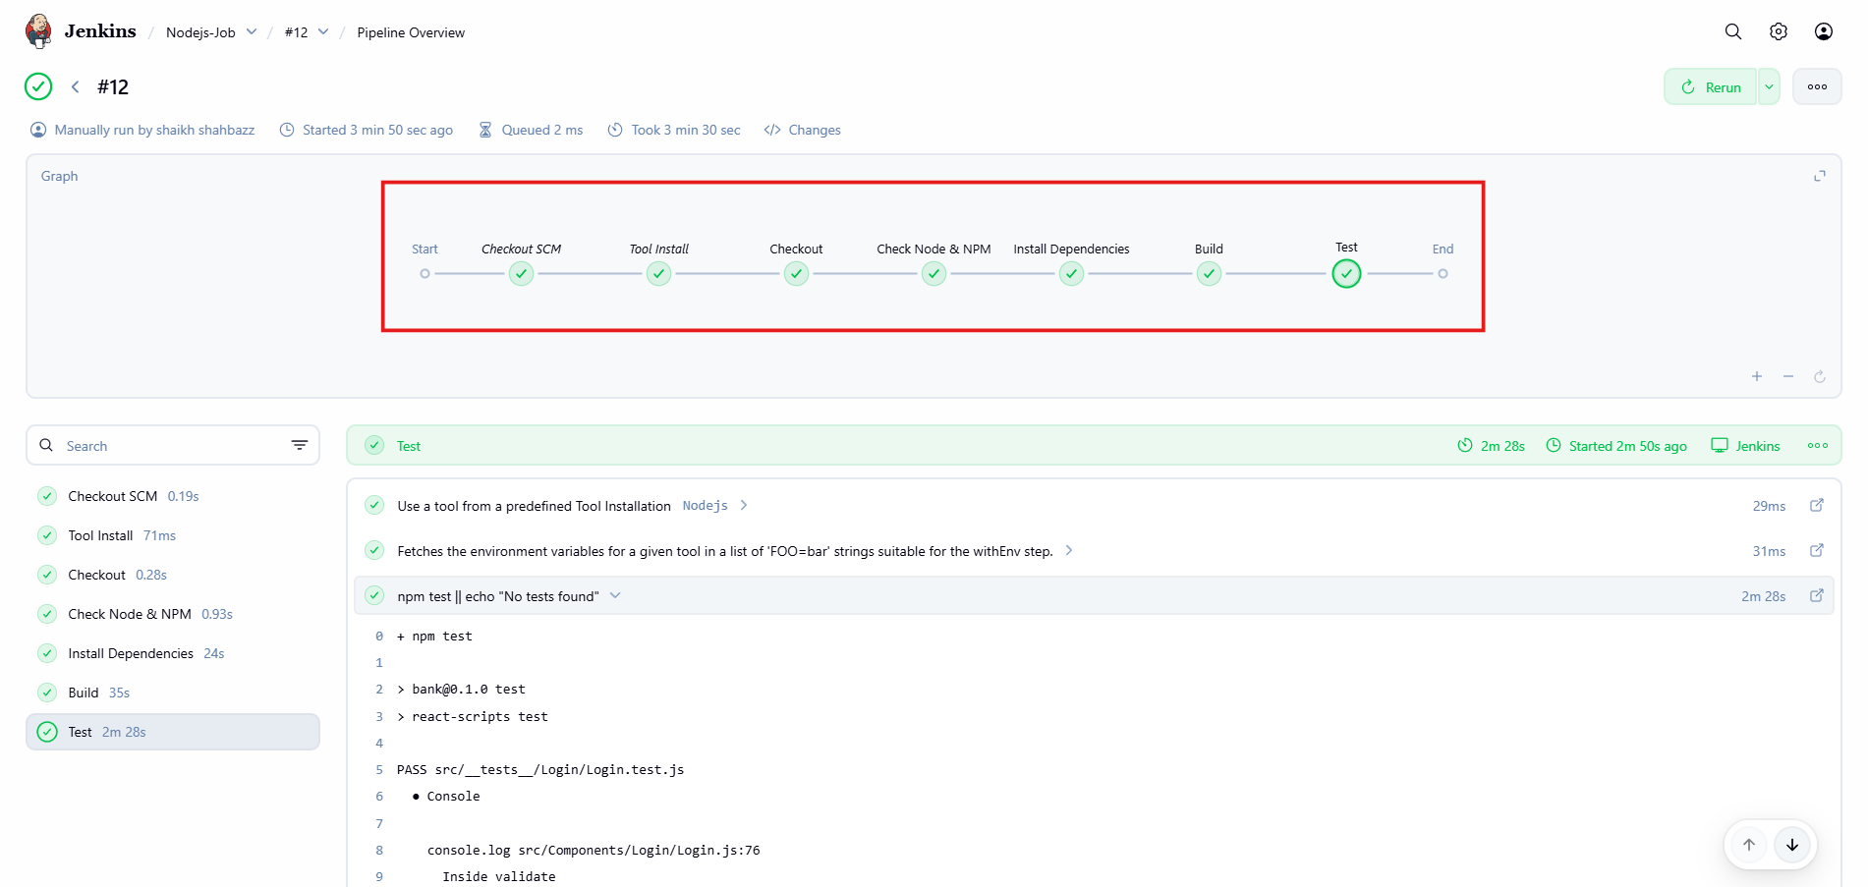

5. Explain 10 Maven commands.

1. mvn clean
What it does: Deletes the target/ directory (compiled classes,
JARs, reports, old builds).
Use Case: Use this before a fresh build to remove old or
corrupted files.
mvn clean
2. mvn compile
What it does: Compiles Java source code from src/main/java
into target/classes.
Use Case: Checking if your Java code contains compilation
errors.
mvn compile
3.mvn test
What it does: Runs all unit tests located in src/test/java.
Use Case: To validate business logic, before merging code.
mvn test
4.mvn package
What it does: Compiles code, runs tests, and packages it into
JAR, WAR, or EAR (based on project type).
Use Case: Generate a deployable artifact.
mvn package
Output:
target/myapp-1.0.jar OR target/myapp-1.0.war
5.mvn install
What it does: Packages the project and installs it into the local
Maven repository (~/.m2).
Use Case: When other projects on the same system depend on
this artifact.
mvn install
6. mvn deploy
What it does: Builds the package and uploads it to a Remote
Maven Repository / Nexus / Artifactory.
Use Case: For CI/CD, when publishing artifacts for other
developers or servers.
mvn deploy
7. mvn verify
What it does: Runs all checks—tests, packaging, integration
tests—before deployment.
Use Case: Use in CI pipeline to ensure build quality.
mvn verify
8. mvn dependency:tree
What it does: Shows detailed hierarchy of project
dependencies.
Use Case:
Detect version conflicts✔
Find transitive dependencies✔
Debug dependency issues✔
mvn dependency:tree
9.mvn help:effective-pom
What it does: Shows the final merged POM, including
inherited and default configurations.
Use Case: Understanding how Maven resolves final
configurations.
mvn help:effective-pom
10. mvn spring-boot:run (for Spring Boot projects)
what it does: Runs the Spring Boot application without
packaging.
Use Case: Quick testing without jar file creation.
mvn spring-boot:run

